Solar Tracker using LDRs and PV Cells

Hammad Khan (9978)
BE-Mechatronics
Karachi Institute of Economics and Technology
Karachi, Pakistan
hammad.khan3019@gmail.com

Abstract— Solar tracker using LDR and PV Cells using maximum electricity generation
Keywords—Solar Tracker, LDR, PV Cells, MPPT, Sensor and Actuator

Introduction
Solar energy is an abundant and renewable source of power that holds significant potential for meeting our growing energy needs. Solar trackers are devices that optimize the positioning of solar panels or solar collectors to maximize their exposure to the sun's rays throughout the day. By tracking the sun's movement, solar trackers increase the efficiency of solar energy systems, resulting in higher energy production.

Solar Tracker Using LDR, Light Sensor, and PV Cells is a system that utilizes LDRs or light sensors in conjunction with PV cells to optimize the orientation of solar panels. By detecting the intensity of sunlight from different directions, the tracker determines the direction of maximum sunlight and adjusts the panel's orientation accordingly. This document provides an overview of its working principle, applications, mathematical formulas for angle calculation, and considerations for electricity generation.

Working Principle
The system employs LDRs strategically placed on the solar panel to capture light information from various angles. By comparing readings from multiple sensors, the direction of maximum sunlight is determined, enabling adjustment of the solar panel's orientation. PV cells, acting as both sensors and energy converters, convert received sunlight into electrical energy when properly oriented towards the sun. Continuous tracking of the sun's movement allows the solar panel to optimize its angle, maximizing energy generation throughout the day.

Applications and Uses
Solar power generation systems for residential, commercial, or industrial buildings.
Portable solar panels or solar-powered devices for outdoor activities.
Solar-powered street lights or outdoor lighting systems.
Off-grid power solutions in remote or rural areas.
Solar-powered charging stations for electric vehicles.

Mathematical Formulas

A. Solar Declination Angle (δ):
The solar declination angle represents the angular distance between the sun and the Earth's equatorial plane. It varies throughout the year due to the Earth's axial tilt. The calculation formula is given as:
δ = 23.45 * sin [(360 * (284 + N)) / 365]
where N represents the number of days since January 1st.

B. Solar Altitude Angle (αThe solar altitude angle represents the angle between the sun and the observer's horizon.

It can be calculated using the following formula:
α = arcsin [sin(φ) * sin(δ) + cos(φ) * cos(δ) * cos(ω)]
where φ represents the observer's latitude and ω represents the solar hour angle.

WORKING CODE
#include <math.h>

// Function to read LDR or light sensor values
int readLightSensor(int sensorPin) {
// Code to read LDR or light sensor value from the specified pin
// Return the sensor value
}

int main() {
// Initialize variables and pins
int sensor1Pin = 0; // LDR or light sensor pin 1
int sensor2Pin = 1; // LDR or light sensor pin 2
// ...

while (true) {
// Read sensor values from each LDR or light sensor
int sensor1Value = readLightSensor(sensor1Pin);
int sensor2Value = readLightSensor(sensor2Pin);
// ...

// Compare sensor values to determine the direction of maximum sunlight
if (sensor1Value > sensor2Value) {
// Adjust solar panel orientation based on the direction
// where sensor1 is positioned
} else {
// Adjust solar panel orientation based on the direction
// where sensor2 is positioned
}

// Repeat the process for other sensors and tracking algorithms

// Delay or wait for a certain interval before the next iteration
// ...
}

return 0;
}

SCHEMaTIC AND DIAGRAM
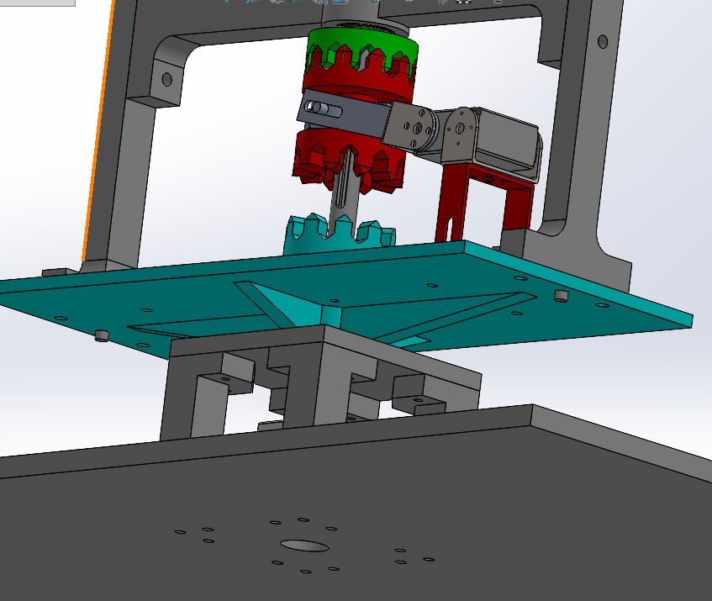
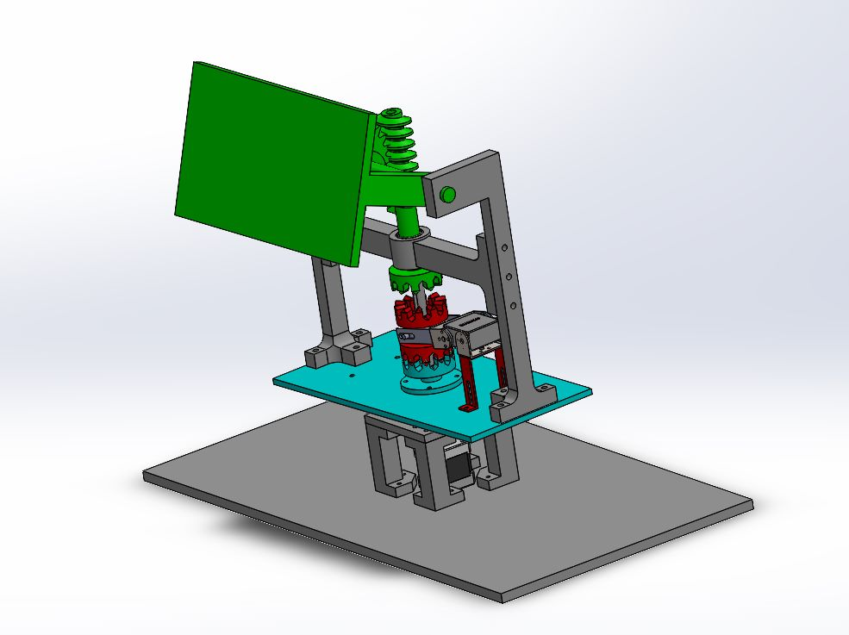
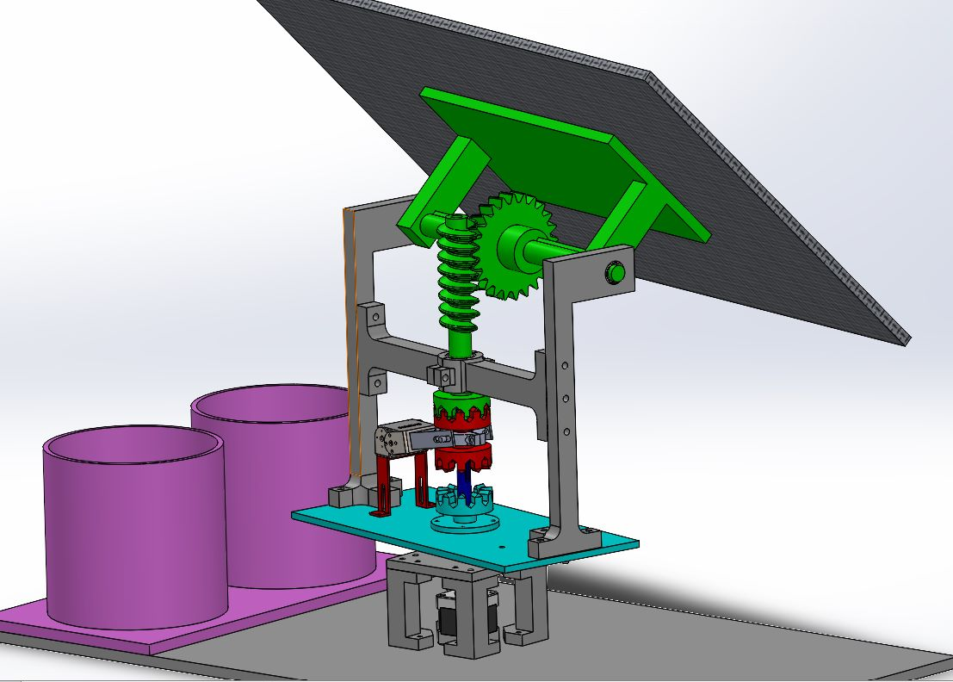

MATLAB WORKING MODEL
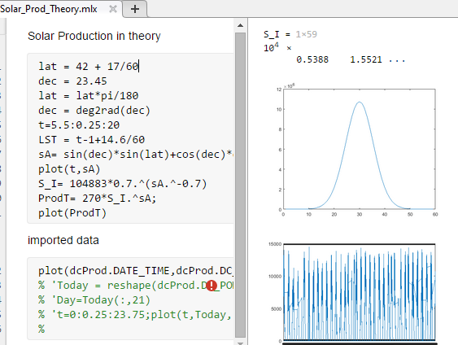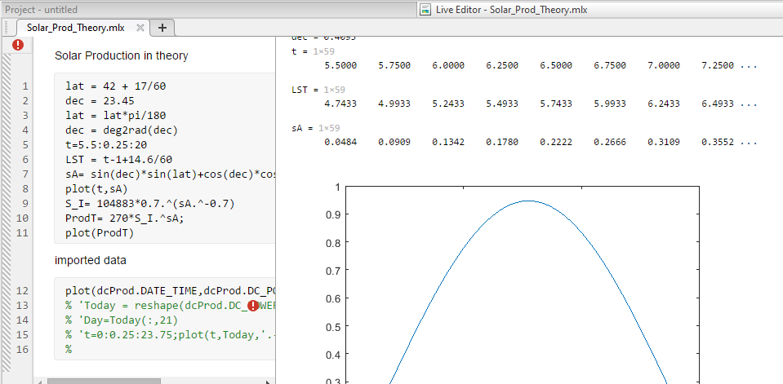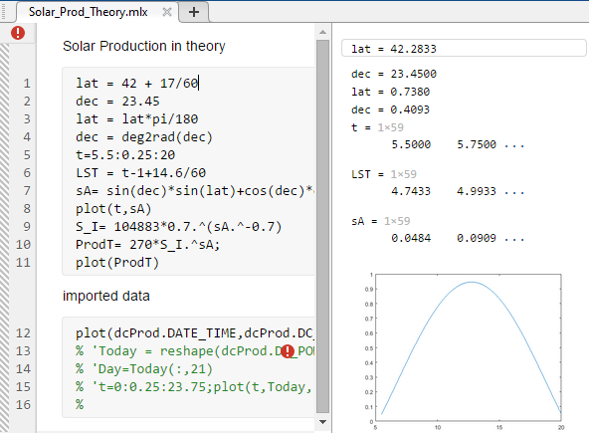

Conclusion
Solar Tracker utilizing LDRs, light sensors, and PV cells provides an effective solution for optimizing the orientation of solar panels. By accurately tracking the sun's movement, it enables improved energy generation. The system finds applications in diverse settings and can contribute to increased efficiency and utilization of solar energy resources.

references

"Solar Tracking Systems: A Review" - by M.M. Saad et al. (2015)
"Solar Tracker System for Maximum Power Point Tracking and Energy Harvesting" - by K. Prasad et al. (2017)
"Design and Development of an Automatic Solar Tracking System" - by D. V. Prasad et al. (2018)

